

2026 Training Manual


Table of Contents
Table of Contents 1
General Instructions 3
Documentation Standards 4
Module 1: Login & System Access 6
A) ACCOUNT CREDENTIALS 6
B) SESSION SECURITY 7
C) ADMINISTRATION 7
D) OWNERSHIP & COPYRIGHT 7
Module 2: The Home Screen & Customer Search 8
A) NAVIGATION 8
B) NEW CUSTOMER 8
C) EXISTING CUSTOMER 9
Module 3: Entering Customer Information 10
A) CUSTOMER CONTACT FIELDS 10
B) CUSTOMER CONTACT ERRORS 11
C) NAVIGATION & FORM BEHAVIOR 12
Module 4: Creating a Ticket 13
A) TICKET INFORMATION FIELDS 13
B) DEVICE PHOTOS – step by step 14
C) PROBLEM / STAFF NOTES – best practice 14
D) NAVIGATION & FORM BEHAVIOR 15
Module 5: Ticket Summary, Signature & Submission 17
A) TICKET REVIEW 17
B) DISCLAIMER & E-SIGNATURE 18
C) PRINTING DEVICE LABELS 18
D) TICKET SUBMISSION 18
Module 6: Admin Portal & Security 21
A) NAVIGATION 21
B) ADMIN PORTAL BUTTONS 22
C) CHANGE PASSWORD 23
D) END ALL SESSIONS 24
Module 7: Viewing & Searching Tickets 25
A) VIEWING RECENT TICKETS 25
B) VIEWING EXISTING TICKET 26
C) SEARCHING SPECIFIC TICKETS 27
Module 8: Generating Reports 28
A) FILTERS & PARAMETERS 28
B) DATE RANGE 29
C) DEVICE TYPES 29
D) COLUMNS TO INCLUDE 29
E) REPORT GENERATION 30
FEEDBACK FORM & THANK YOU 31

General Instructions
Welcome to the WildRose Portal training! This binder will guide you through our web application and act as a reference guide if you run into any issues. Please read the following instructions before we begin.
During the Training Session:
- Follow along with the instructions in this binder
- Feel free to write notes on the pages or anything useful for your operations
- Ask questions at any time and keep in mind there are no bad questions
- Screen examples may differ from live data, but the functionality is the same
- Each module will focus on one section but may include multiple features

After the Training Session:
- This binder can be kept at your workstation for future reference

Documentation Standards
Consistent and accurate data entry is essential. The standards below ensure that every ticket can be searched, retrieved, and understood by any staff member.
- Customer Information
Field | Format | Example | Required?
First Name | Letters, hyphens, and apostrophes any other characters will not be accepted | John | Yes
Last Name | Letters, hyphens, and apostrophes any other characters will not be accepted | Smith | Yes
Phone Number | ###-###-#### | 403-111-1111 | Yes
Address | Street number + street name | 123 street road | No
Email | Standard email format | John@gmail.com | No

- Device Information
Field | Format | Example | Required?
Device Type | Select from dropdown; use Other if not listed | Laptop | Yes
Brand | Manufacturer name | Apple | Recommended
Model | Full Model Name | MacBook | Recommended
Serial Number | Serial number printed on device | NFJ9339FJDN | No
Password/Pin | Exactly as provided by Customer | password | Yes (only if customer has a password)
Peripherals | Comma separated list of accessories | Power cable, mouse, and keyboard | If applicable

- Staff Notes Standards
- Describe the problem the customer reported as specifically as possible
- Include any promises or timelines discussed with the customer
- Avoid abbreviations or slang unfamiliar to other staff

- Photo Standards
- Capture any pre-existing scratches, cracks, or damage
- Ensure photos are clear and in focus

- General Data Entry Rules
- Never leave staff notes blank, always document the reason the customer brought in device
- If a customer has no password check the box rather than entering a placeholder
- Proofread the ticket summary before submitting

Module 1: Login & System Access
Welcome to the WildRose Portal.
Module Objectives
1. Learn the account credentials
2. Understand how to login to the WildRose Portal web application
3. Understand WildRose Portal’s ownership and copyright

Overview
After loading the WildRose Portal web application, you will be greeted with a login screen.
Please click the text box and enter in the information provided below for the AltisMSP account and click Log In to proceed. Ensure the customer can’t see you entering in this information.
There is a Show password toggle for convenience which will make the password you’re typing visible.
Proceed to login with Section A credentials.

ACCOUNT CREDENTIALS
Username: AltisMSP
Password: Password1
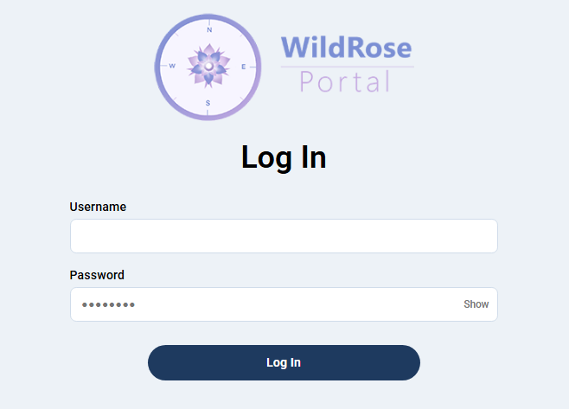

SESSION SECURITY
When a user logs in to the WildRose Portal, there is something created called a session ID. This is important to know for security purposes.
There are different levels of security in the WildRose Portal, including but not limited to session expiry.
Sessions will expire after 10 hours from application launch. This is to ensure the web application isn’t running too long after store closing hours if it isn’t manually logged out.
In the case of theft of the tablet, there is also an End All Sessions button which we will discuss in module 6.
There is also the ability to change the AltisMSP account password within the web application. This will also be elaborated on in module 6.
Finally, it should be disclosed for security purposes administrators have access to the source code, database and separate account credentials.

ADMINISTRATION
Other administrative materials regarding our web application are not present in this manual. This means the Admin account, GitHub repository, source code, database manager, DreamHost PHPMailer or Microsoft Azure Backup solution are not relevant for training.

OWNERSHIP & COPYRIGHT
The WildRose Portal web application was created by FireNode for AltisMSP in Lethbridge Alberta in partnership with Lethbridge Polytechnic’s Computer Information Technology Program 2026. All rights reserved by FireNode and AltisMSP.

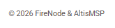

Module 2: The Home Screen & Customer Search
Module Objectives
1. Understand how to check-in a device for a new customer
2. Understand how to check-in a device for a returning aka “existing” customer
3. Understand how to navigate to the Admin Portal

Overview
This is the Main Menu of the WildRose Portal. You have three navigation options. We will focus on New Customer and Existing Customer in this module.
Is this the first time a customer has visited Altis? See section B.
Has the customer been here before? See section C.

NAVIGATION
- Clicking the New Customer button will start the device check-in process. This will be expanded on in section B
- Clicking the Search Bar and typing something in will start the existing customer workflow. This will be expanded on in section C
- Clicking the Admin Button will direct you to the Admin Portal for administrative options including the ability to log out. This will be discussed in module 6

NEW CUSTOMER
Click the New Customer button when a customer arrives with a device for repair but hasn’t visited since the launch of WildRose Portal. This will direct you to the Customer Contact Form to proceed.
Good practice might be to ask, “Have you been here before since we got the tablet?” if the answer is no, click the New Customer button. If the answer is yes, see section C.

EXISTING CUSTOMER
This is a search bar for finding customers who have had a device repaired before. Search results won’t appear until precisely 2 characters have been typed. You may see customer names if the information provided matches information in the database. The 10 most relevant search results will be suggested.
When you click a suggested customer, you will be directed to the Customer Contact Form, and the fields will be automatically filled in with their information.
Click the search bar and enter the customer’s name, phone number or email.
Then click the suggested customer.
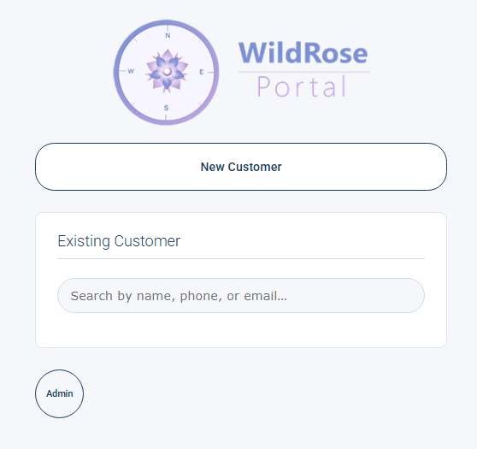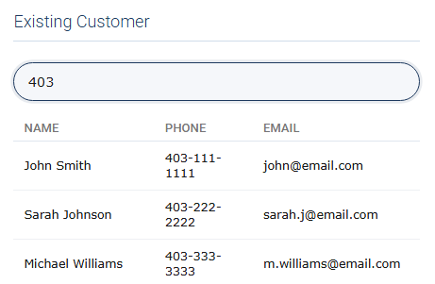

Module 3: Entering Customer Information
Module Objectives
1. Enter the customer’s information in the required fields
2. Proceed to the Ticket Information screen

Overview
The Customer Contact form starts the intake process. This will ensure the relevant information is needed to identify and contact the customer. You may turn the tablet for the customer to enter their information in themselves or enter it on their behalf, whichever is more convenient at the time of service.
Please be aware, there is a message at the bottom to hand the tablet back to the staff member, but there will not be a pop-up if they navigate to a different page. It would be best practice to let them know to hand it back, or to retrieve it from the customer after they’ve entered their information.
Type in the customer’s information.

CUSTOMER CONTACT FIELDS
First Name: * Enter in the customer’s first name. This is required to identify the customer. The character limit is 45. This field won’t accept numbers or special characters.

Last Name: * Enter in the customer’s last name. This is required to identify the customer. The character limit is 45. This field won’t accept numbers or special characters.

Phone Number: * Enter in the customer’s phone number. This is required as it is the primary and preferred method to contact the customer. The character limit is 10. Please note the dashes “-” are entered automatically for convenience.
This field won’t accept letters or special characters.

Address: You may ask for the customer’s address. This is optional. This is good practice if contact is lost with the customer. After an egregious extended period, you may want to consider shipping the device back to the customer's address. The character limit is 45. Letters, numbers and special characters are permitted.

Email: You may ask for the customer’s email address. This is optional. It is good practice to ask if the customer would prefer contact via phone number or e-mail. The character limit is 82. Letters, numbers and special characters are permitted. There are several checks in place to ensure a correct e-mail is input.

As previously mentioned, this information will be automatically entered if you went through the Existing Customer workflow. It’s good practice to ensure that the customer’s information is still up to date. If you change the customer’s information here, it will be updated in the database for next time.

CUSTOMER CONTACT ERRORS
There are errors or red lines which will appear beside the respective, incorrect field if something goes wrong.
A red line may occur without an error message if something was incorrectly typed in an incorrect succession.
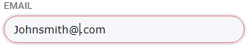
This error occurs if a required field noted with a * is left blank.
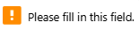
This error occurs if you input incorrect characters in that field.
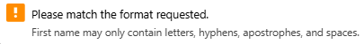
This error occurs if you don’t include an @ character in the email address.
This error occurs if you exceed the email character limit.

NAVIGATION & FORM BEHAVIOR
Next: Clicking Next will save the information in the session data, so if you come back to this page the information will still be there. Additionally, this information will update the customer’s information in the database after the ticket is submitted.
Cancel: Clicking Cancel will delete the information you have enterred.
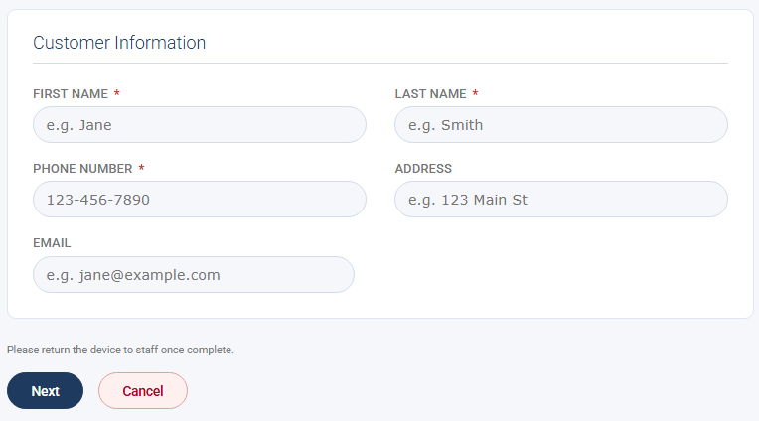

Module 4: Creating a Ticket
Module Objectives
1. Select the correct Device type from dropdown menu
2. Enter Device details including brand, model, serial number, and password
3. Document Peripherals and add staff notes describing customer issue
4. Set the Label quantity
5. Capture device photos using the tablet’s camera
6. Proceed to the Ticket Summary screen

Overview
The Ticket information form is intended to capture everything needed to identify the device and understand the customer’s issue. Take your time here as accurate information prevents problems later. This information should be entered by staff to ensure complete and detailed information.
Enter the device information, issue(s), 1 label per peripheral and take photos.

TICKET INFORMATION FIELDS
Device type: * Allows you to select from the following options:
Laptop – portable computers,
Desktop – towers,
Printer – inkjet, laser, or multifunction printer,
Other – Enter a custom device type in the text box that appears.
Brand: The Manufacturer of the device (Ex: Apple, Dell, Lenovo)
Model: The full model name can be found in system setting or on device label.
Serial Number: The unique alphanumeric identifier for the device. Found on the bottom label, inside the battery compartment, or in system settings
Password/Pin: * The device login password/PIN as provided by customer. The field hides characters for privacy. If device has no password check ‘No Password on this device’ instead of leaving blank.
Peripherals: A list of all accessories and items included with the device.
Staff Notes: * The staff entered a description of the customer’s issue and the reason they are checking in the device for service. This acts as the primary communication between intake staff and the technicians.
Labels: The number of adhesive labels to print for this device use the + and – buttons to increase or decrease the count Labels will print in the next step. Default count is 1.
Device Photos: Photos of the device captured using the tablet’s camera. Used to document the condition of the device at intake, including any pre-existing damage

DEVICE PHOTOS – step by step
The device photo section uses the tablets camera to capture images of the device being dropped off. This documents its condition at intake and protects both the customer and AltisMSP.
- Select Rear or Front camera using radio buttons (Rear Camera is recommended)
- Click Start Camera. If prompted by browser click Allow to grant camera access
- The live camera will start indicated by LIVE badge
- Then capture the photo
- The photo will appear under the camera box to verify picture quality
If the Camera does not start check browser permissions to use the camera and allow for this site.

PROBLEM / STAFF NOTES – best practice
When writing staff notes include the following where possible:
- What the customer says is wrong: describe the problem in their words
- When it happens: does it occur at startup, during use, randomly?
- Any relevant history: like recent drops, updates, or spills
- What the Customer is asking for: repair, diagnosis, or data backup etc
- Any commitments made: turnaround time, cost estimates etc

NAVIGATION & FORM BEHAVIOR
Next: Saves ticket information into session data and proceed to ticket summary screen
Cancel: Cancel the check-in process and return to the home screen all entered data will be lost.
Previous: Saves entered ticket information and returns customer to Customer contact form.
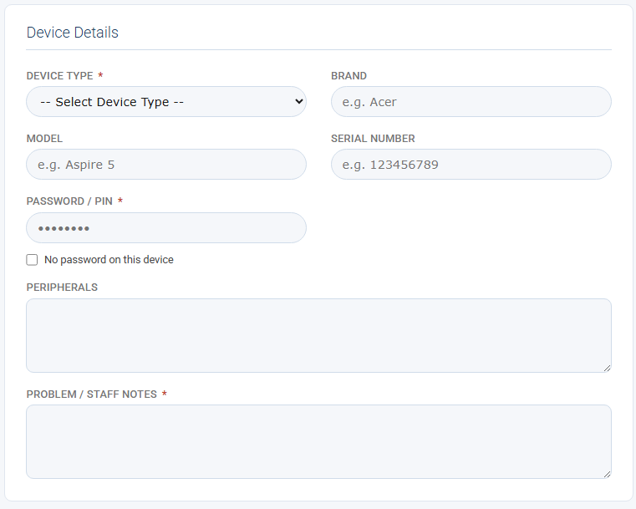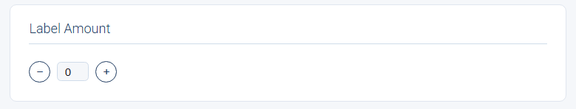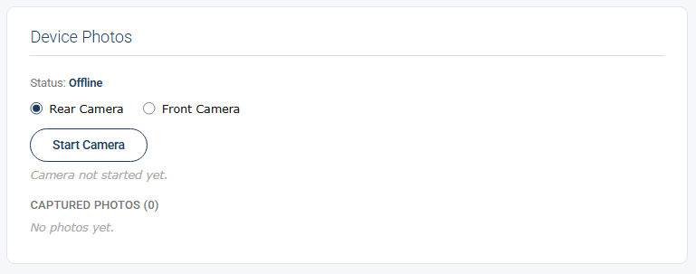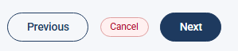

Module 5: Ticket Summary, Signature & Submission
Module Objectives
1. Understanding how to review the ticket before it is submitted
2. Understanding how to retrieve the customer’s signature for the ticket
3. Understanding how to print the device labels and submit the finished ticket

Overview
The ticket summary page is the final step in the process of ticket creation. Here we can double-check the customer’s information, the ticket information, get a signature, print labels, and complete the final submission of the ticket. Carefully review all the necessary information because once the ticket is submitted, no changes can be made.
Review the information and collect the customer’s electronic signature.

TICKET REVIEW
When you arrive at the Ticket Summary page, review each section carefully before proceeding:
- Customer Information: Confirm the customer's name, phone number, address, and email are correct. The badge next to the section heading will indicate whether this is a New or Existing customer
- Device Information: Confirm the device type, brand, model, serial number, password, peripherals, and staff notes are all accurate
- Device Photos: Confirm any photos taken of the device are visible and clearly show the device's condition

It is good practice to go through this page one section at a time before getting them to sign. This will help build trust and avoid errors.

DISCLAIMER & E-SIGNATURE
Scroll down to the Terms & Conditions section and ask the customer to read through the service agreement. Once they are satisfied, ask them to sign in the signature box using their finger or a stylus.
- If the customer makes a mistake, the Clear Signature button will erase the signature so they can start over
- A signature is required before the ticket can be submitted.
- If no signature is detected when you tap Submit, you will be prompted to confirm if you want to continue without one

PRINTING DEVICE LABELS
The Print Label section will display the number of labels selected during the Ticket Information step. Tap the Print Label button to send the label job to the Dymo Printer.
- The quantity printed will match what was set on the previous page. If the quantity is wrong, use the Back button to return and adjust it before printing
- Attach the printed label to the customer's device before they leave

TICKET SUBMISSION
Once you have reviewed all information, collected the signature, and printed the label, tap the Submit Ticket button.
- Submitting the ticket will create a new customer record if this is a new customer, or update the existing customer record if they have visited before
- A new device record and ticket will be created in the database
- An alert will appear confirming the submission was successful and prompting staff to retrieve the tablet from the customer
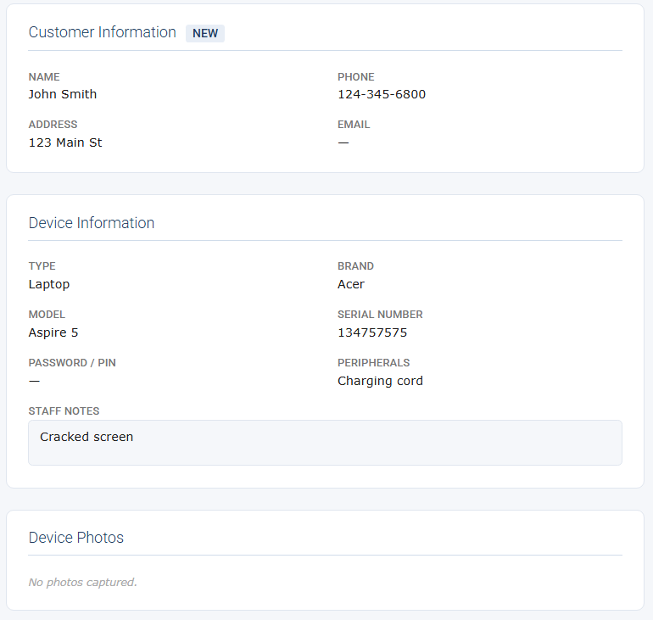
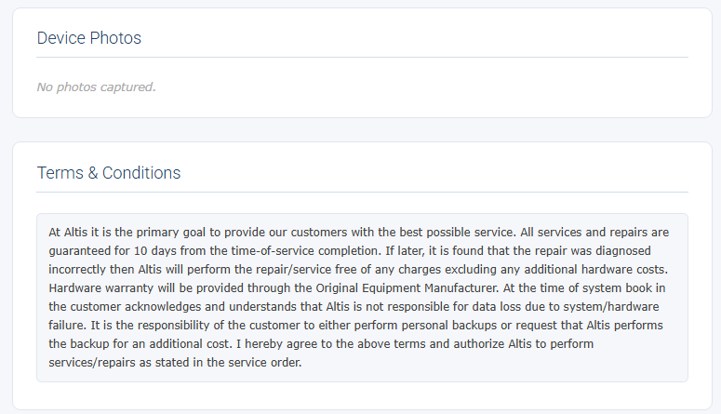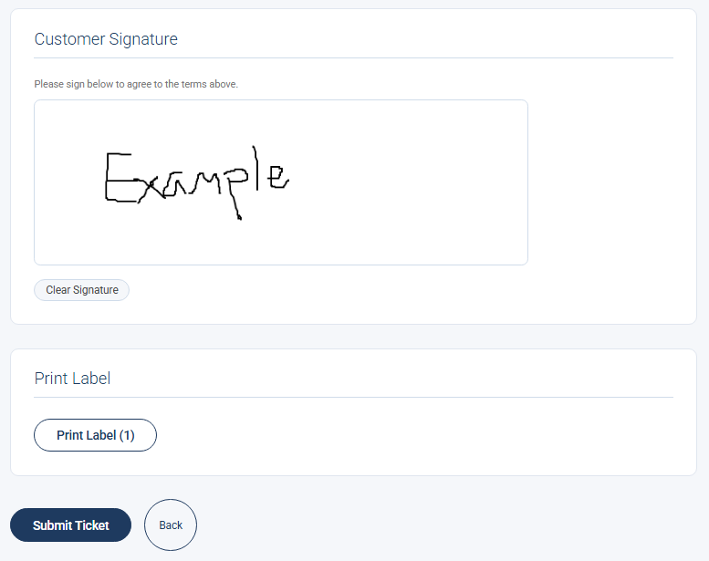

Module 6: Admin Portal & Security
Welcome to the Admin Portal.

Module Objectives
1. Understand how to navigate inside the Admin Portal
2. Understand what is on the Admin Portal
3. Understand how to use the Change Password function
4. Understand how to use the End All Sessions function

Overview
This is the Admin Portal home page of the WildRose Portal. You have six navigation options available at this point. Please see section A to understand how to proceed.

NAVIGATION
After clicking the Admin button on the main menu it will take you to the Admin Portal. From the Admin Portal page, you can do a multitude of things such as view previous tickets with the View Tickets button. You can create reports with the Create Report button. Or you can change the password with the Change Password button, and more.
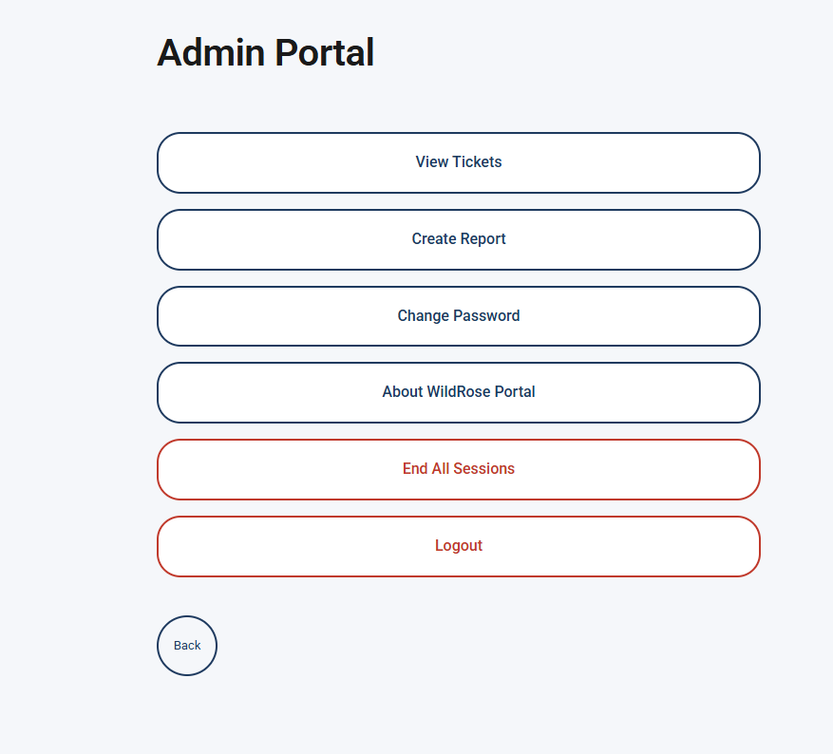

ADMIN PORTAL BUTTONS
Button Name | Description | When you would use it
View Tickets | Allows you to view previous ticket that have been made. You can search by name, phone number, device type, or ticket#. It only shows the ten most recent of what you search | You would use this when you want to see the most recent tickets that have been made
Create Report | Allows you to create reports from all the previous tickets. You can also choose what to sort by and customize what is on your report | You would use this when you want to see how many laptops have been checked in and by who
Change Password | Allows you to change the password on this account | You would use this if someone finds out the password to this account
About WildRose Portal | It gives a description of the WildRose Portal, who FireNode is, and every member of FireNode | You would use this if you were curious about who FireNode is and how made the WildRose Portal
End All Sessions | Allows you to logout every device that is currently logged in wherever they are. Including your own | If someone were to get access to the web server that you don’t want to
Logout | Logs-out the current user | Use this when you want to logout of the WildRose Portal
Back | Sends you back to the main page | Use this when you want to leave the Admin Portal and back to the main page

CHANGE PASSWORD
Clicking the Change Password button will take you to the change password page. Once you are on the change password page you will enter the current password for this account. Then you will enter the new password twice to make sure they are the same password.
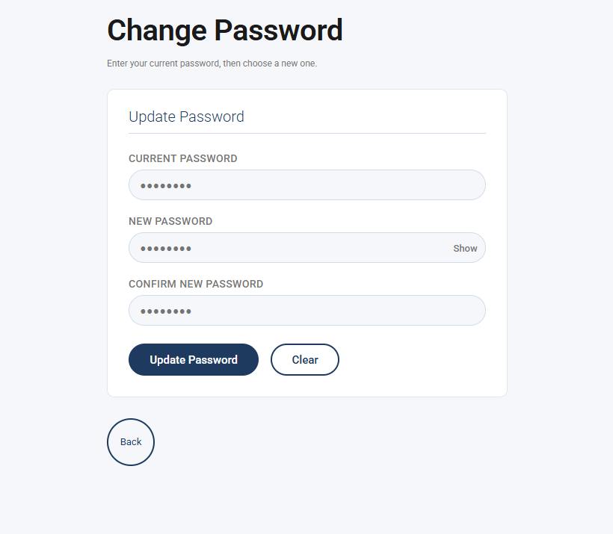

END ALL SESSIONS
Clicking the End All Sessions button will take you to the End All Sessions page. You can click the next End All Sessions button or Cancel. Cancel will take you back to the Admin Portal page. Clicking this End All Sessions button will prompt you with a warning. If you click the End All Sessions button again at this point, it will log every account out.
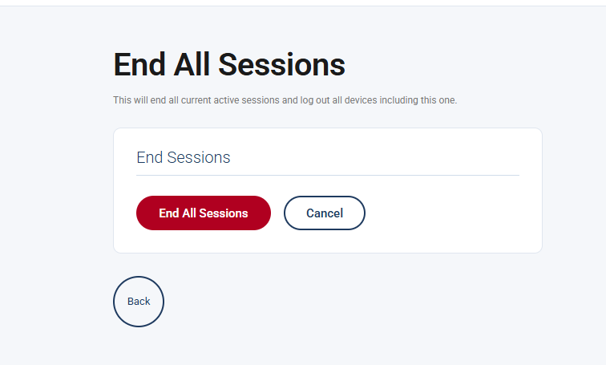
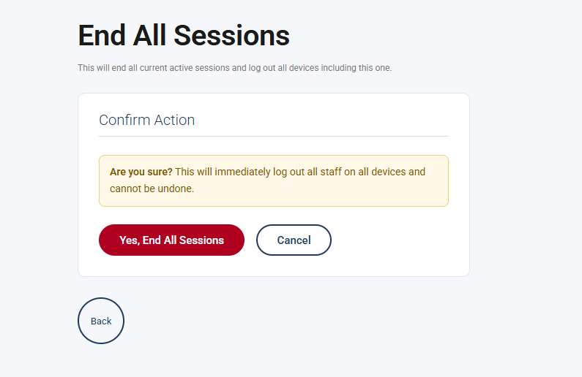

Module 7: Viewing & Searching Tickets
Module Objectives
1. Understand how to view tickets
2. Understand how to search for tickets

Overview
This is how to use the View Ticket page of the WildRose Portal. You can search for tickets by different categories. Please see section A to understand how to proceed.

VIEWING RECENT TICKETS
Once in the Ticket page it will automatically show the ten most recent tickets that have been made using the WildRose Portal.
Each ticket shown will show the ticket #, date, customers name, and device type.
You can click on a ticket to open the ticket summary. See section B for more information.
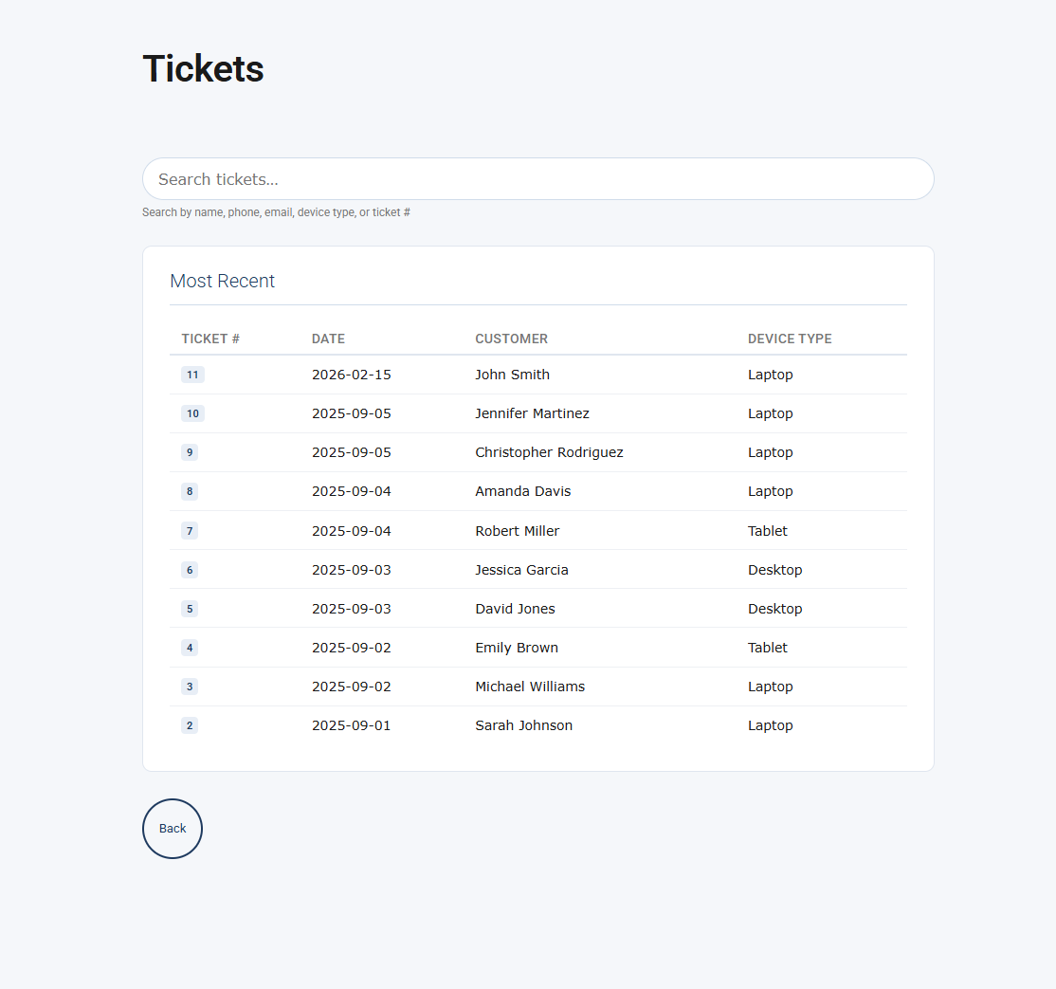

VIEWING EXISTING TICKET
Once a ticket has been opened the ticket summary will be displayed. You may click the Back button to be returned to the Tickets page.
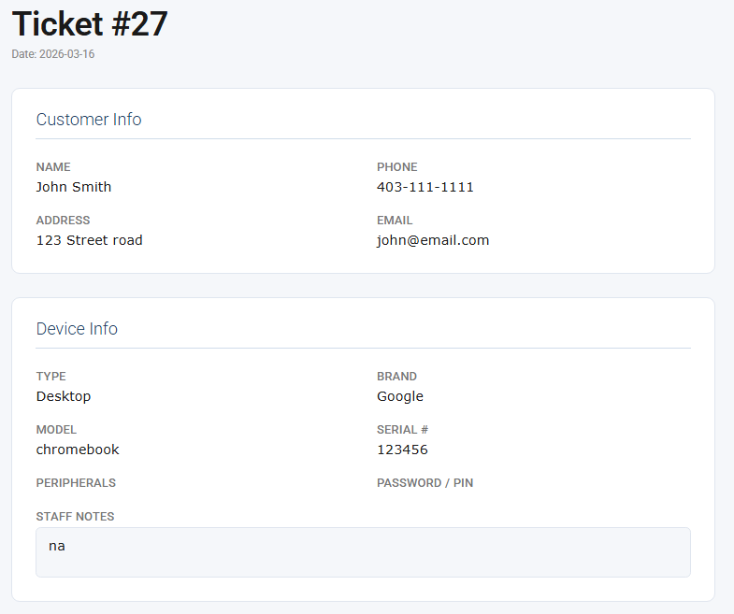
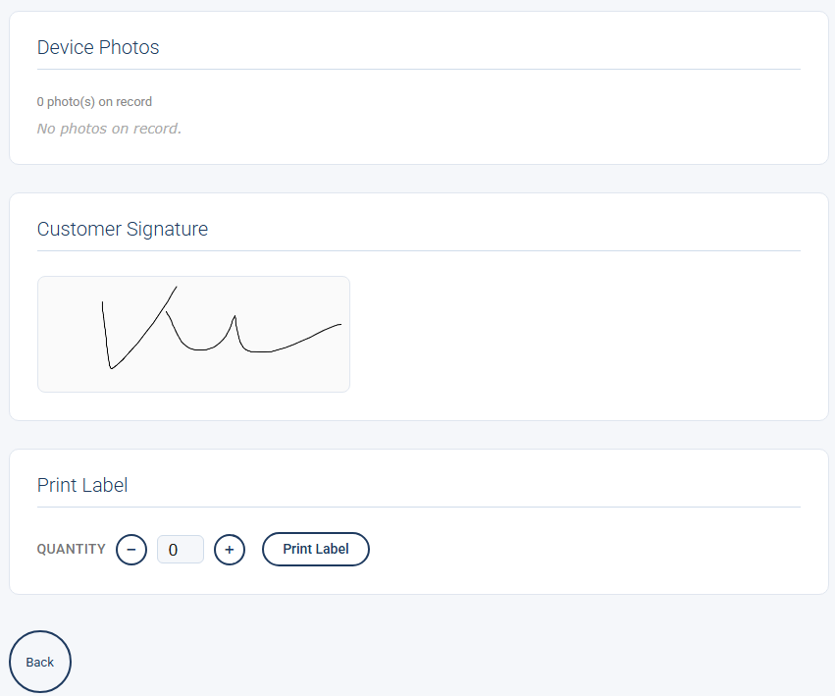

SEARCHING SPECIFIC TICKETS
On the Tickets page, you can search for specific tickets by clicking the text field and entering the ticket #, date, customers name, or device type. Once entered it will find the tickets that match the searched criteria.
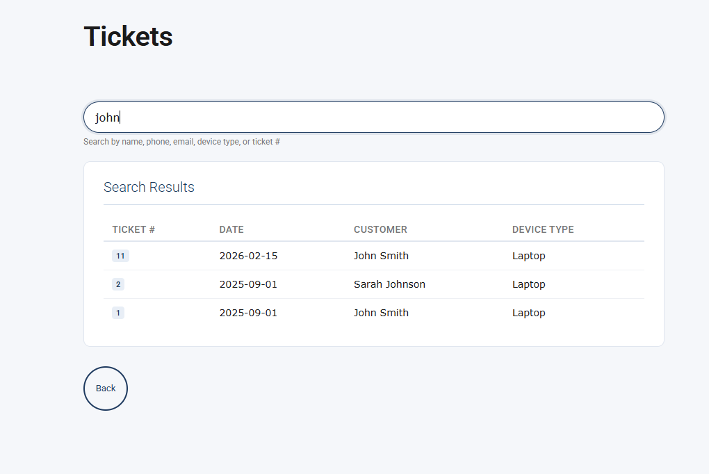

Module 8: Generating Reports
Module Objectives
1. Understand how to navigate the reports page
2. Understand how to generate reports
3. Understand how to save a report

Overview
This shows how to customize and generate reports using the Create Report page. Please see section A to understand how to proceed.

FILTERS & PARAMETERS
Once on the Report Generator page you can select the parameters for your report. There is a way to select the date range. Also, there is a way to select what device types you want in your reports. Lastly you can select what columns you want in your reports. Each part will be explained in more detail in sections B, C, and D.
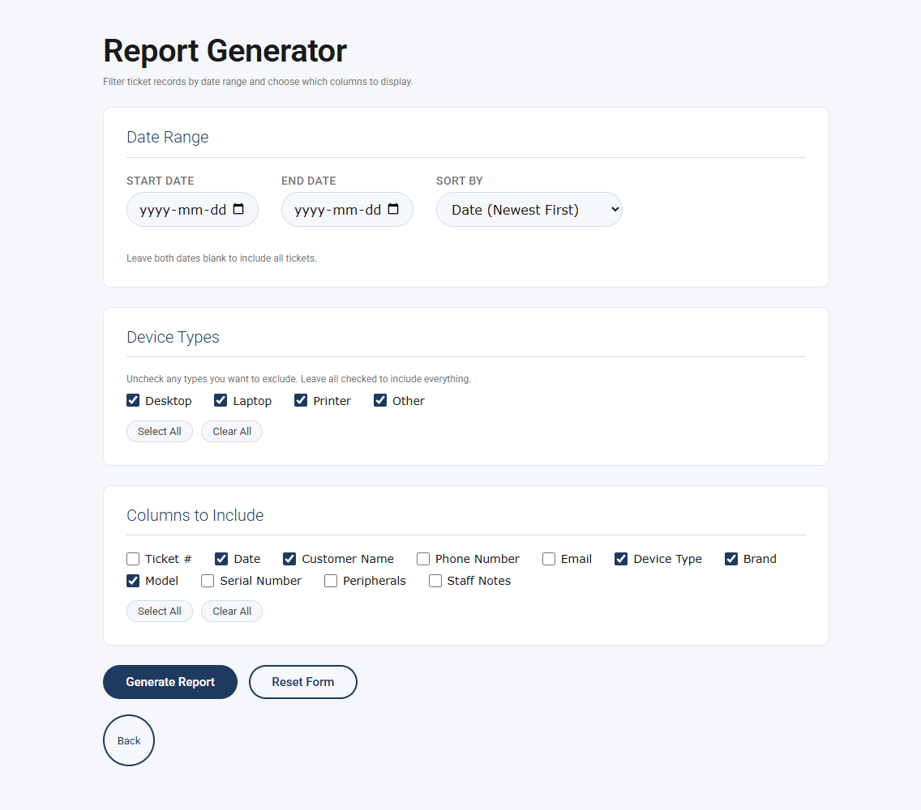

DATE RANGE
When selecting the date range, you can select the start and end date. You can also sort by date (Newest First), (Oldest First), first name, and ticket number. Leaving the start and end dates blank will show the tickets for every date. The default for sort is date (Newest First).
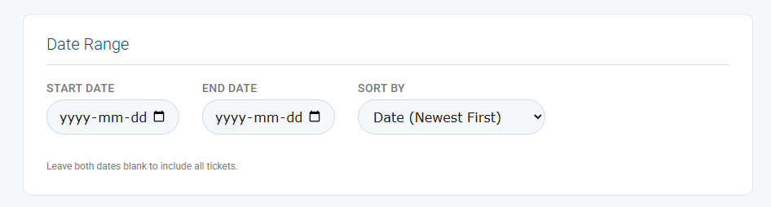

DEVICE TYPES
When selecting the device type you can check off on four types: desktop, laptop, printer, or other. You can select any number of combinations of them. There is also a Select All button and Clear All button. The defaults are all selected.
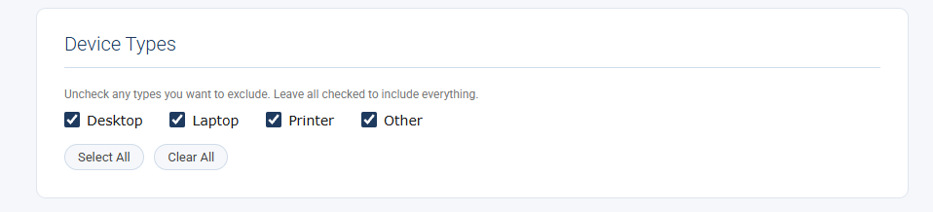

COLUMNS TO INCLUDE
When selecting what columns to include you can pick from ticket #, date, customer name, phone number, email, device type, brand, model, serial number, peripherals, and staff notes. There is also a Select All button and Clear All button. The defaults are data, customer name, device type, brand, and model which are all selected.
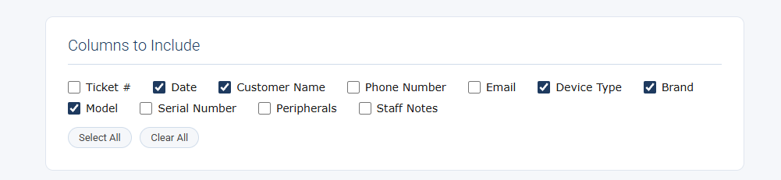

REPORT GENERATION
Click the Generate Report button to generate a report from information that was filled out in sections B, C, and D. The Reset Form button sets the information back to the defaults. See sections B, C, and D for each individual defaults.
Once the report has be generated it will show a preview of the report on the page. Right above the preview there will be a records counter showing how many records are in the report. Below the record counter there is a Print / Save as PDF button that will save the report as a PDF, or you can print it.
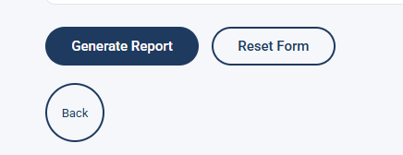
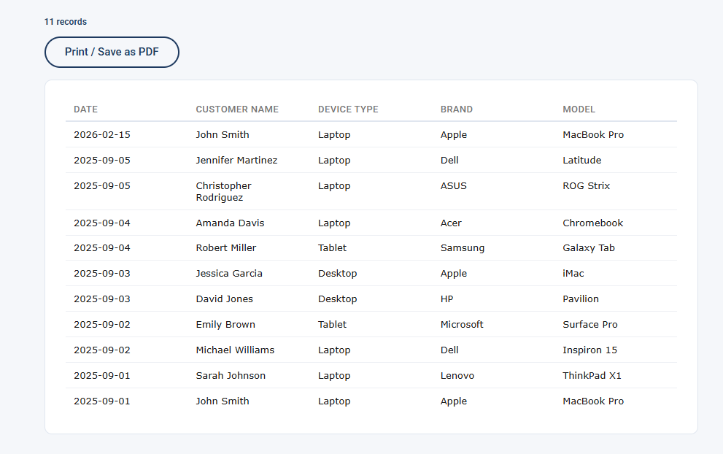

FEEDBACK FORM & THANK YOU
Thank you so much for your time. We encourage you to leave your honest feedback using the form below by scanning the QR code. It will take you to our google document.

Please scan the QR code to submit feedback!


A big THANK YOU to AltisMSP for permitting us to work with your company.
Computer Information Technology, Lethbridge Polytechnic, 2026


FireNode Colors:
#7C8BCC Periwinkle
#BFA9DC Lavender

